**20CP301P – COMPUTER NETWORKS LAB**

NAME : Dev Patel DIV : 3 – G5 ROLLNO: 22BCP185 DATE : 23-07-24

*Network Topologies*

Network topology is the arrangement or pattern of various elements (links, nodes, etc.) in a computer network. It describes how different nodes in a network are connected and how data is transmitted from one node to another.

**AIM: Simulation of Various Networking Topologies**

**Prerequisite: NIL**

**Outcome: To impart knowledge of Computer Networking Technology**

1. **Bus Topology**:

* **Theory:**
  + Bus topology is a network design where all devices are connected to a single central cable, known as the bus. Data sent from a device travels along the bus until it reaches the destination device. The bus must be terminated at both ends to prevent signal bounce, which can cause network errors.
* **Steps:** 
  + Open Cisco Packet Tracer.
  + Place a series of end devices (PCs) in a line.
  + Use a single backbone cable to connect all devices.
  + Add terminators at both ends of the backbone cable.
* **Description**: All devices are connected to a single central cable, called the bus or backbone.
* **Advantages**: Simple to set up and cost-effective for small networks.
* **Disadvantages**: If the main cable fails, the entire network is disrupted; limited cable length and number of devices.

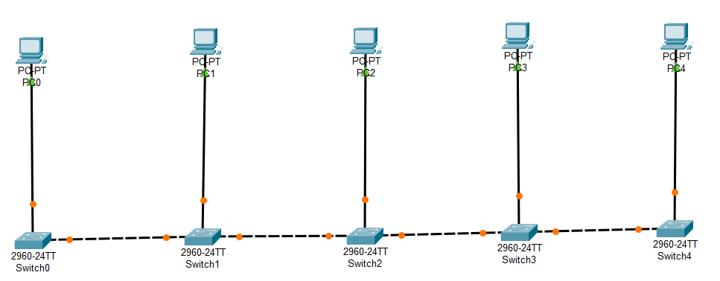

**2. Star Topology**:

* **Theory:**
  + Star topology is a network setup where each device is connected to a central switch or hub. All data traffic passes through the central hub, which manages and controls the network traffic. This design offers robust performance and simplifies troubleshooting.
* **Steps:**
  + Place a switch in the center.
  + Connect each end device (PCs) to the switch using Ethernet cables.
* **Description**: All devices are connected to a central hub or switch.
* **Advantages**: Easy to install and manage; a failure in one cable does not affect other devices.
* **Disadvantages**: If the central hub fails, the entire network goes down; can be more expensive due to the cost of the hub.
* **Observation & Learnings**:
  + Simple to implement but difficult to troubleshoot.
  + Performance degrades as more devices are added.

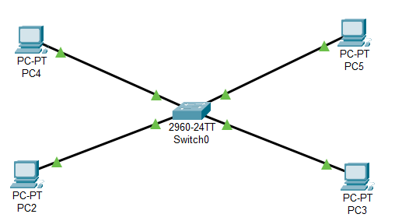

**3. Ring Topology**:

* **Theory:**
  + In a ring topology, each device is connected to exactly two other devices, forming a circular data path. Data travels in one direction (or both in a dual ring) and passes through each device until it reaches its destination. This setup helps manage traffic but can be disrupted if any single device or connection fails.
* **Steps:**
  + Place end devices in a circular layout.
  + Connect each device to two other devices using Ethernet cables to form a ring.
* **Description**: Devices are connected in a circular fashion, forming a closed loop.
* **Advantages**: Data travels at high speeds; easy to identify and isolate faults.
* **Disadvantages**: A failure in any single device or cable can disrupt the entire network; more difficult to install and reconfigure.
* **Observation & Learnings**:
  + Easy to manage and troubleshoot.
  + A single point of failure is the central switch.

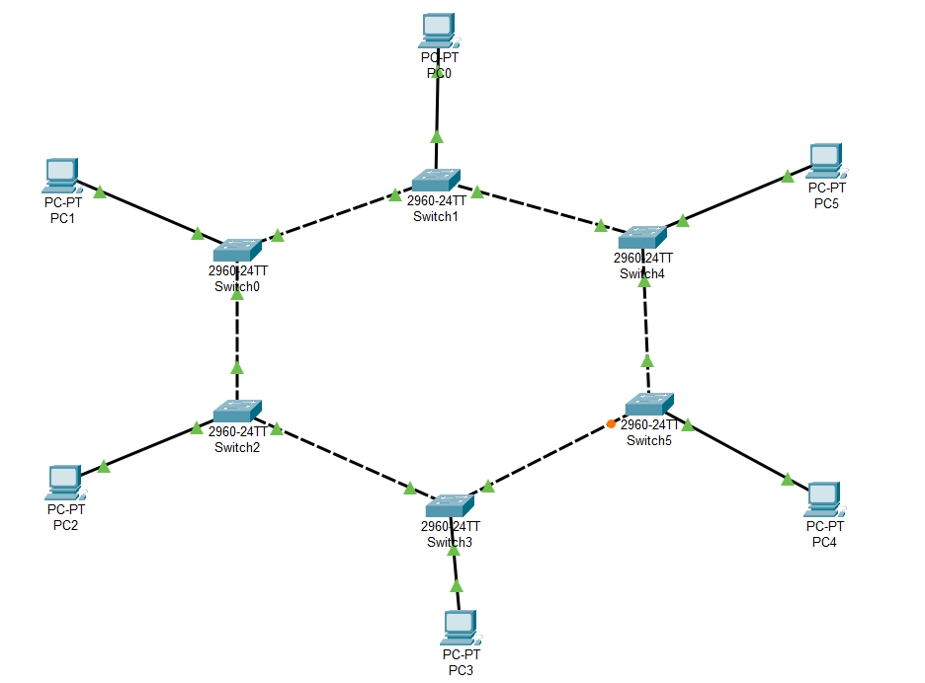

**4. Mesh Topology**:

* **Theory:**
  + Mesh topology involves connecting each device to every other device in the network. This setup provides multiple paths for data to travel, ensuring high redundancy and reliability. Mesh topology is often used in critical network environments where uptime and reliability are paramount.
* **Steps:**
  + Place multiple end devices (PCs).
  + Connect each device to every other device with Ethernet cables.
* **Description**: Every device is connected to every other device in the network.
* **Advantages**: High reliability and redundancy; multiple paths for data transmission.
* **Disadvantages**: Very complex and expensive to install due to the high number of connections.
* **Observation & Learnings:** 
  + Provides high redundancy and reliability.
  + Complex and expensive to implement due to the number of connections.

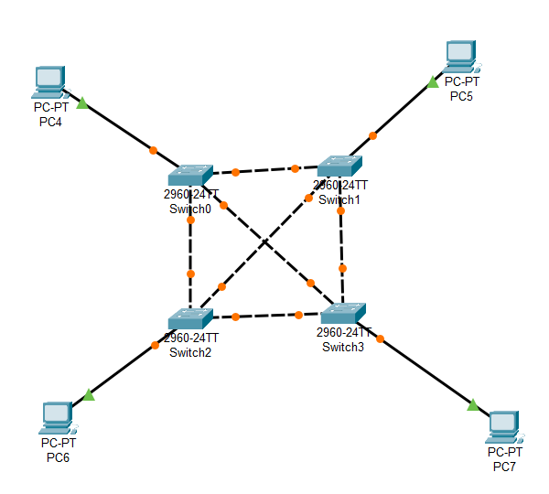

**5. Tree(Hierarchical) Topology**:

* **Theory:**
  + Tree topology combines characteristics of both star and bus topologies. It features a hierarchical structure with a root switch connected to multiple levels of intermediary switches, each connecting to devices or other switches. This design is commonly used in large networks to segment and manage different areas.
* **Steps:**
  + Place a main switch as the root.
  + Connect the main switch to multiple intermediate switches.
  + Connect each intermediate switch to end devices (PCs).
* **Description**: A hybrid topology combining characteristics of star and bus topologies, with groups of star-configured networks connected to a linear bus backbone.
* **Advantages**: Scalable and easy to manage; allows for the addition of more devices.
* **Disadvantages**: If the backbone line fails, the entire network segment can be affected.
* **Observation & Learnings**:
  + Combines characteristics of star and bus topologies.
  + Scalable and easy to manage, but the main switch is a point of failure.

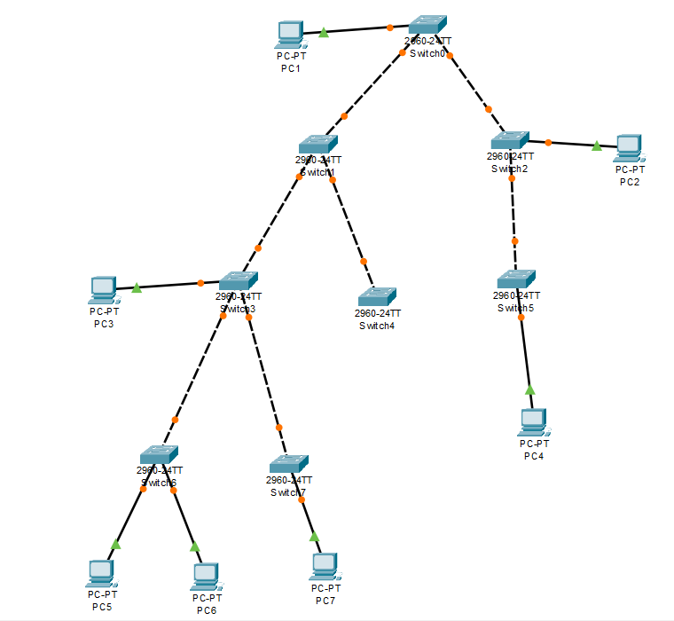

**6. Hybrid Topology**:

* **Theory:**
  + Hybrid topology combines two or more different types of topologies to leverage the advantages of each. For example, a star-ring hybrid might connect several star networks in a ring configuration. This approach offers flexibility and optimized performance for specific network requirements.
* **Steps:**
  + Combine elements of the above topologies (e.g., star-bus or star-ring).
  + Place a switch and connect it to end devices (PCs) in a star formation.
  + Connect additional switches to the main switch and form a bus or ring with these switches.
* **Description**: Combination of two or more different topologies.
* **Advantages**: Flexible and scalable, accommodating large and complex network designs.
* **Disadvantages**: Can be complex and expensive to design and maintain.
* **Observation & Learnings**:
  + Flexible and scalable by combining various topologies.
  + Complex to design and implement, offering the benefits of the included topologies.

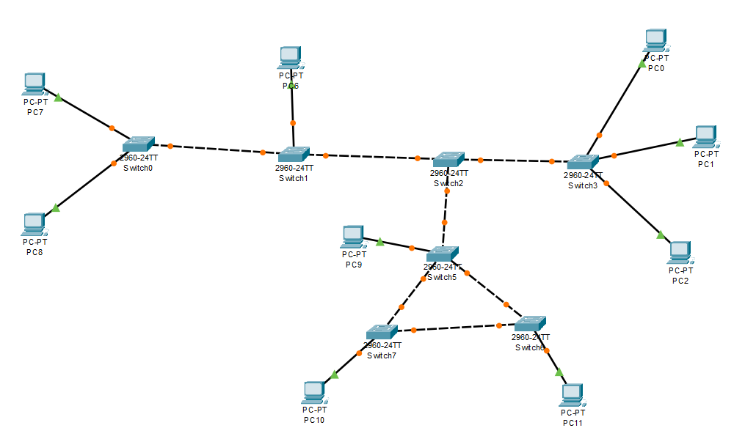

* **Conclusion:**
  + Each topology has its strengths and weaknesses.
  + The choice of topology depends on the specific requirements of the network, such as scalability, budget, and reliability.
  + Star topology is often the most efficient in a LAN environment due to its simplicity and ease of troubleshooting, despite the single point of failure.
  + Using Cisco Packet Tracer, these topologies can be visualized and tested, providing a clear understanding of their practical implementations and behaviors.

**1. Which is the most efficient topology in LAN environment and Why?**

* **Star Topology** is often considered the most efficient for LANs because it is easy to install and manage, offers good performance, and allows for easy troubleshooting. The only drawback is the reliance on the central switch, but this can be mitigated with redundant switches.

**2.** **How can we test the connectivity between the terminals?**

* In Cisco Packet Tracer, you can use the ping command from the Command Prompt of each device to test connectivity. Simply open the CLI of a device, type ping [IP address of the target device], and observe if the packets are successfully sent and received.
* Also we can use packets message in order to know that the message is sent and received or not.

**3. What are the two categories of cable? In what type of connection are they used?**

* **Copper Cables**: These include Ethernet cables (e.g., Cat5, Cat6) and are typically used for connections within short distances, such as within a building.
* **Fiber Optic Cables**: These cables are used for high-speed data transfer over long distances, often used for backbone connections between switches in different buildings or data centres.

Name: Dev Patel Div: 3/G5 Roll No. : 22BCP185 Date: 30/7/2024

* **AIM:**
* **Prerequisite:**
* **Outcome:**

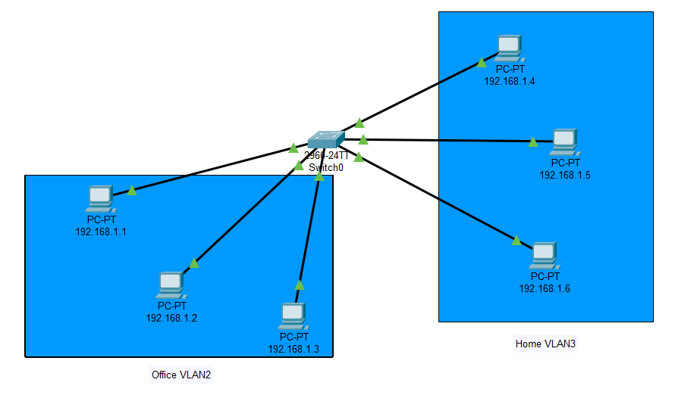

* **Theory:**